The Next Level
Nate Heiss
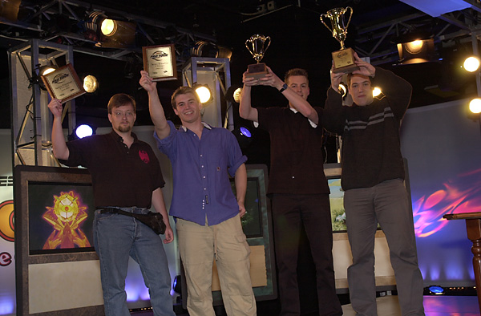
It takes some work to get here.
Many people play Magic casually and enjoy the game at a leisurely pace with their friends in a comfortable environment. Some of these players, at times, have wondered what it would be like to play in their first Pro Tour Qualifier. Others dream about what it would be like to win a big event. There are many players that have been gaming in a casual environment that simply want to get better at the game and play more competitively.
Where games are concerned, having fun and playing with friends are the most important factors. However, when gamers get that competitive urge, there is no stopping them. I have received many requests for tips on how a normal player can become more competitive and perhaps even make the Pro Tour. As a wide response, this article details a few of the steps to the next level of play.

The first thing to know is the location of the tournaments in your area. In my area (Pittsburgh, PA...home of the Penguins and Steelers), there are only one or two qualifiers in the city per Pro Tour. I usually have to travel about 3.5 hours in order to double the number of chances I get. Many regions across the US have only one qualifier per Tour and some Magic players have to drive across states in order to get to it. Check with Wizards.com in order to find out about more qualifiers in your area. If there is nothing close to you, do not get discouraged. There are also many events that take place in your local card store. Some places hold Friday Night Magic, Arena, or in-house tournaments. All of those are great options for improving your game so that when you do decide to drive across the state to play in a Qualifier, you will be prepared.
When initially trying to become more competitive, keep in mind that while it may seem like the winners of any particular tournament are very random, you will notice a few people that consistently do well at each one. Let those people be your inspiration during hours of despair. I say this because everyone despairs now and then when tournaments are involved. Perhaps you will find yourself on a losing streak or your mana might refuse to work right; look to the people who consistently do well and know that a higher level of play truly does exist and anyone can attain it. Knowing that everything is not completely random can be comforting when you are trying to improve your game. You must have a positive attitude toward improving your game while understanding that it will not be easy to accomplish and that it will not come immediately.
The most important thing to do at a tournament is to keep your perspective. Remember why you are there; to improve you game while enjoying more competitive Magic. Take small steps, improving different things you see wrong. You should be able to catch yourself making mistakes if you pay attention. Take your time if necessary, but do not put everyone to sleep either. If you do not learn to play correctly at a normal pace, then you will be bowled over by opponents that think and play faster then you. Try to relearn the game, understanding the building blocks of strategy. Work to make your technical play as flawless as possible. Study the rules of the game in order to play your cards properly and identify when others are not. Pay attention to your opponent and find his mistakes as well. Remember everything you have learned and put it to good use. This process may take a long time to complete. Even I find quite a few play errors in my game. Some are plain eyesores while others are subtle and can only be detected with a trained eye (luckily for me, CMU has many 'trained eyes' running about). The ability to detect the small errors as well as the large ones are equally important for improving your overall play.
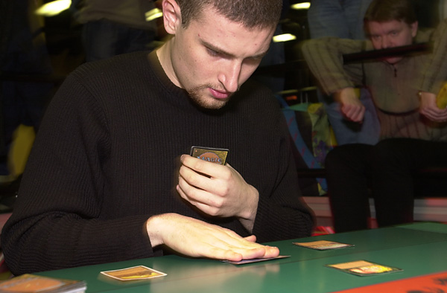
Undoubtedly, you will reach a point where you can no longer find fault in your game. I assure you that it is still there, but you need help to see it. I imagine that even Jon Finkel makes play errors, but there is no one better than him to detect it. Ask a better player to watch your games. This is where it helps to have a friend trying to improve alongside you. Even if they are only slightly better then you, a team effort can yield greater and faster results. I have the benefit of my cousin and teammate, Mike Turian, to confide in. We both agree that we would never have done as well as we did if it was not for the players that surrounded us. Many Team CMU discussions are centered on the correctness of a particular play in a specific game. The entire format may have rotated out, but we would still theorize about the right play for months on the principle of improving our game. Be careful though; sometimes theorizing too much can be a pitfall where reality is removed from the play in question. Dan Silberman and I have sat in front of each other with two different decks, discussing how the match-up should go instead of shuffling the cards in front of us and playing it out. Reality is usually a better indicator of fact than theory, no matter how much I prefer the latter.
Most of your initial improvement will come in technical play, while the later improvement will come in your decision-making process and theory. As long as you take small steps, any obstacle can be overcome. Keeping a positive attitude will help prevent you from creating your own impenetrable wall. When in doubt, simply play more Magic! No one has ever gotten worse at the game by playing it more. If you feel burned out by playing at a more complex level, take awhile and play a more casual format. Do some Two-Headed Giant drafts or get into a Grand Melee game. I find Grandmaster (the one where you keep your opponent's sealed deck and incorporate it into your own after you win) to be one of the most fun tournament formats around. Do not lose sight of the real reasons why you play the game just because you want to get to the next level.
Eventually, you will feel like you deserve to qualify or win a tournament. Assuming that you do your homework and understand how to play the environment, you should experience increasingly better average results. Remember that you will have your good days and bad days, so don't be discouraged by a slump.
Following the guidelines above will help any player improve their game, not only casual players looking for the next level. I use all of the techniques myself and can plainly see all of the room for improvement. Keeping the right attitude and reasonable expectations is the key to improving your game, while getting discouraged can be a major setback. Anyone can be the next Randy Buehler or Darwin Kastle; all it takes is loads of practice and unfaltering persistence.

